National Institute of Health Research
Health Informatics Collaborative (Critical Care)
Standard Operating Procedure for Data Release

Document control
Date created | 2016-09-10
Date modified | 2016-10-25
Date approved
Version | 0.9.003

1. Introduction
This document specifies the framework for releasing data collated for the Critical Care theme of the National Institute of Health Research's Health Informatics Collaborative (NIHR HIC). These data are portions of the electronic health records related to an episode of critical care. They have been assembled to enable clinical and health science research teams to interrogate these rich data streams with the aim of improving the care of future patients.
While supporting this academic programme, we need to protect the existing patients from whom these data have been abstracted. The data are stored securely using the Identifiable Data Handling Solution at University College London (UCL IDHS) which is certified to the ISO27001 information security standard and conforms to the National Health Service (NHS) Information Governance Toolkit.
We have followed the principles of patient confidentiality from the NHS Code of Practice in preparing this document. (1)
To protect – look after the patient’s information. The data handling and storage is discussed elsewhere. The scope of this document is limited to anonymisation steps for data release.
To inform – ensure that patients are aware of how their information is used. We will make this document, and the methods we use for anonymisation publically available. We have already, and will continue to engage with patients and their representatives to ensure that the processes of using these data are transparent.
To provide choice – allow patients to decide whether their information can be disclosed or used in particular ways. We will provide easily accessible opt-out mechanisms for patients who do not wish to have their data released.
To improve – always look for better ways to protect, inform, and provide choice. We will review this document annually, and through external audit, re-identification challenges, and public scrutiny continually improve these processes.
We envision two scenarios in which data may be released from the IDHS.
1. Raw data for analysis
2. Summarised data for research publication
The first of these carries the greatest risk with respect to information security. The second refers to the release of data summaries, tables, and figures where the individual records are not exposed. The same standards of security will apply to both scenarios but the inherent aggregation of data in the latter will mean that most data has already been pre-processed to meet these standards.

2. Principles
(a) Definition of personal data
We will be following the guidance provided by the Information Commissioner's Office (ICO) in 'Anonymisation: managing data protection risk code of practice' (2012). (2) The legal basis for this guidance comes from the Data Protection Act (DPA) 1988, and Recital 26 of the European Data Protection Directive (95/46/EC) which in turn is based on the following principles.
• "Personal data has to be about a living person, meaning that the DPA does not apply to mortality or other records about the deceased"
• that "information or a combination of information, that does not relate to and identify an individual, is not personal data"
Importantly, the guidance from the ICO states that there is "clear legal authority for the view that where an organisation converts personal data into an anonymised form and discloses it, this will not amount to a disclosure of personal data".
(b) Definition of likelihood of re-identification
The DPA does not require that it is impossible to re-identify an individual from disclosed data, but that defines personal data as those where is the risk of re-identification is "likely". We are expected to take three factors into account.
• the likelihood of identification being attempted
• the likelihood of identification being successful
• the quality of the data after the anonymisation has taken place.
Medical data will present a likely target for re-identification, and more so where it includes information on VIPs (e.g. public figures, politicians, celebrities). Although, we can minimise this risk by removing the records of VIPs from released data, the risk remains to others.
We therefore have concentrated on making the likelihood of re-identification unsuccessful. This has to be balanced against the utility of the data after anonymisation has been performed which, in turn, requires measures of the disclosure risk, and of information content.
(c) Measuring disclosure risk
There is a trade off between information loss and disclosure risk so that as the risk of disclosure decreases then so does utility of the data.
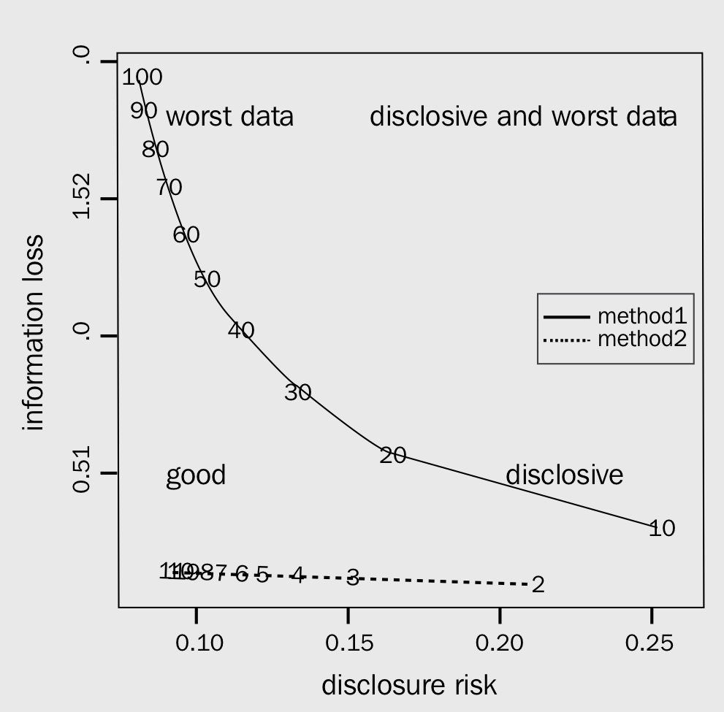
To define this we need to measure the information content, and quantify the disclosure risk. Ignoring direct identifiers which must be removed, then it is still possible to re-identify individuals using other charactertics. We describe this risk using two terms.
K-anonymity counts the number of individuals identified by the intersection of key variables. We would wish this to be ten or greater. For example, if we release individual data describing 'species', and 'favourite sandwich filling', then the intersection of 'bears' and 'marmalade' would uniquely identify Paddington Bear. If we generalise 'favourite sandwich filling' to 'prefers sweet sandwiches' then because Pooh Bear likes honey as well as Paddington liking marmalade, the k-anonymity would rise to two.
L-diversity counts how varied other sensitive fields are within a k-anonymous group. Continuing the example above, if we had a data item 'fictional character', then a child wondering if Pooh really lived in the 100 acre wood would be able to confirm that, since all individuals in the group are fictional, this cannot be true.
These concepts can be used to classify data fields into the following categories.
Direct identifiers | These must be removed from the data.
Key variables | A k-anonymity threshold must be set which defines the group size that would result if the key variables were used together to attempt to re-identify individuals.
Sensitive fields | These are fields that would reveal information about individuals in the data set even when the k-anonymity threshold was not breached.
Non-identifiying variables | These are the remaining variables after defining the direct identifiers, key, and sensitive variables.

3. Anonymisation methodology
We have adapted guidance for National Statistical Offices (e.g. the UK's Office of National Statistics) produced by the International Household Survey Network in its 'Introduction to Statistical Disclosure Control'. (3)
We have divided the steps that may be taken to anonymise the data into the specific (with respect to these data), and the general (that apply to all data). A template flow diagram that summarises these steps is provided. Each data release will be expected to adapt this template where necessary, and then seek specific approval for those adaptions.
(a) Specific measures
The following steps will be perfomed before assessing any information loss.
Step (1) Removal of direct identifiers
All unique identifiers including NHS number and hospital number will be removed from the data before release.
Step (2) Remove living subjects (where possible)
The DPA only applies to living individuals. Where possible, data will only be released for patients who are known to have died. Where the analysis depends on comparisons of survivors and non-survivors, these additional data must be specifically requested.
Step (3) Date and time metadata
All data items within the data carry a two metadata timestamps. One relates to when that data file was created, and is used for internal audit of the data (i.e. when a data item has been updated). This will be discarded before any data release. The second relates to the date and time when an observation was recorded. These carry a re-identification risk as they narrow down the number of observations that might relate to any particular individual. We will convert all of these to data and time differences from critical care admission before data release. For example, a heart reate measurement will be defined as occurring 24 hours after ICU admission, but it will not be possible to know the day, month or year of that measurment. Where a researcher intends to study a phenomenom that depends on these characteristics (e.g. the 'weekend' effect) then the minimum data and time information necessary for the analysis will released.
Step (4) Remove high risk individuals and specific opt-outs
The participating hospitals will inevitably care for well known public figures from time to time, and to avoid attempts at their re-identificaton we will prospectively remove their health records from any data release. The MIT team running the MIMIC critical care database in Boston resorted to a similar strategy when they discovered that users were trying to identify the health records of the victims of the Boston Marathon bombings in 2013.
Specific patients may also have notified the data controller through the CCHIC team that they do not wish their data to be shared. These records would also be removed before release.
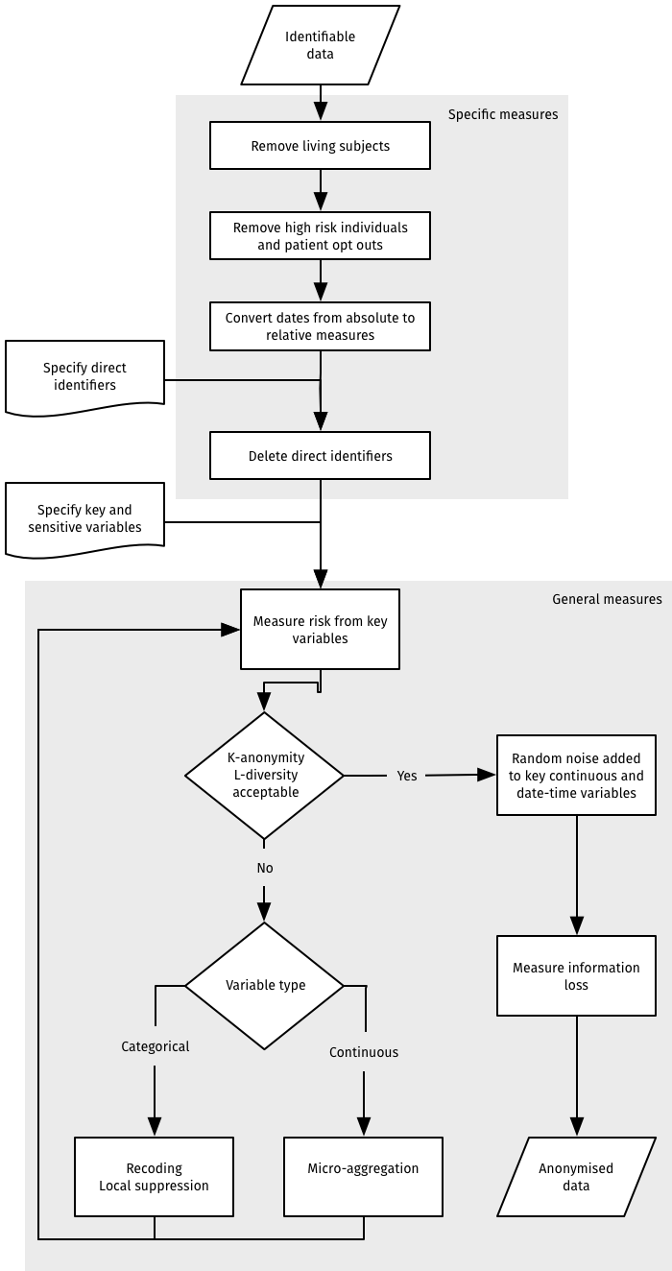
(b) General anonymisation methods
The remaining key and sensitive variables will be processed using the thresholds for k-anonymity and l-diversity. Where these thresholds are exceeded, one or more of the following techniques will be applied, the disclosure risk re-assessed, and this process will be continued iteratively until the data meet the pre-specified thresholds.
Recoding Categorical variables are combined into super-categories that contain less information than the original variable (e.g. age in years is recodeded to age in ten year bands). Top and bottom recoding is a special case of the above where the sparsely populated extremes are recoded into bands (e.g. age in years over 100 is recoded to 80+) thereby minimising the risk of re-identification without losing information in already populous categories.
Local suppression This is method normally applied to key variables that when present reduce the k-anonymity measure below the desired threshold. By replacing the values of a small number of these observations with missing values, then it increases the k-anonymity measure, and makes it more difficult to triangulate any particular individual.
Post-randomisation Categorical data is perturbed by randomly re-assigning observations to a different category. The user specifies the probabilities that an observation in one category is transformed to another. For example, if eye colour is a category then you might specify that 'blue' eyes have a 10% chance of being relabeled as 'grey' and a 1% chance that they are relabeled as 'brown'. In this way, the user specifies the trade-off between information loss and disclosure risk.
Micro-aggregation This method is applied to continuous variables. The variable is divided into categories by an automatic algorithm and then replaced with a summary statistic for that category. Height, for example, might be recoded into quintiles and replaced with the median value for each quintile. Various automatic grouping algorithms exists which differ, as usual, in the trade-off between information loss and disclosure risk. Most are 'computationally' expensive (i.e. take time to run on even a fast computer).
Adding noise Adding noise is another method for handling disclosure risk for continuous key variables. Each observation is perturbed by sampling from a noise distribution, and adding that amount of noise to the measure. The parameters of the noise distribution are adjusted to preserve, where possible, the mean and the variance of the original data.
Shuffling This is a more complex 'multivariate' approach to adding noise that attempts to preserve relationships between variables as well as the summary characteristic of the original variable. In brief, if we were trying to reduce the disclosure risk for patient weight it would be important to take account of height and sex before adding noise. We would then build a regression model in the original to predict weight from height and sex. Instead of using the predictions from the model, we would rank the predicted values, and the original values. We would then replace the original value with a prediction of the same rank. Continuing the example, assuming tall men weight the most, we would use the actual weight of the tallest man to replace the original value of the heaviest person in the original data even if that person was female.
(c) Measure information loss
We will aim to preserve the structure of the data where possible. For example, rather than recoding age into age bands (a categorical variable), we will preferentially add noise so that the variable remains continuous. In order that researchers can understand the fidelity of the data we will also aim to report measures of information loss. In the first instance, we will reproduce a standard severity of illness model (e.g. APACHE II (4)), and then report differences in measures of fit between the identifiable and non-identifiable data sets.

4. Governance
(a) Central data management
Critical Care's Health Informatics Collaborative (CC-HIC) is a collaboration between the five Biomedical Research Centre's at Cambridge, Guy's and St Thomas', Imperial, Oxford, and UCL. A theme board comprising the clinical and programme management team oversees a working group at UCL who manage the programme on behalf of the board. The management structure is as follows:
• Data controller: Professor Mervyn Singer (UCL)
• Data custodian: Professor Graham Hart (UCL)
The data controller reports to the CC-HIC board, and may nominate others to manage the data releases such that they meet the standards described here. These individuals must be made known to the CC-HIC board so that a direct line of responsibility is maintained.
In addition, we undertake to:
• review this policy annually
• submit the policy and procedures to an annual internal information security audit
• submit the policy and procedures to an annual external information security audit
• keep all other approvals up-to-date (e.g. Research Ethics, and Clinical Advisory Group approval)
(b) Data user's responsibilities
Data users will be expected to sign an end user license agreement that is modelled on that used by the UK Data service (see https://www.ukdataservice.ac.uk). It can be summarised with the following sixteen points.
1. to use the data in accordance with the EUL and to notify the Critical Care Health Informatics Collaborative of any breach you are aware of
2. not to use the data for commercial purposes without obtaining permission and, where relevant, an appropriate licence if commercial use of the data is required
3. that the EUL does not transfer any interest in intellectual property to you
4. that the EUL and data collections are provided without warranty or liability of any kind
5. to abide by any further conditions notified to you
6. to give access to the data collections only to registered users with a registered use (who have accepted the terms and conditions, including any relevant further conditions). There are some exceptions regarding the use of data collections for teaching and the use of data collections for Commercial purposes to be set out in an additional Commercial Licence.
7. to ensure that the means of access to the data (such as passwords) are kept secure and not disclosed to anyone else
8. to preserve the confidentiality of, and not attempt to identify, individuals, households or organisations in the data
9. to use the correct methods of citation and acknowledgement in publications
10. to send the Critical Care Health Informatics Collaborative bibliographic details of any published work based on our data collections
11. that personal data about you may be held for validation and statistical purposes and to manage the service, and that these data may be passed on to other parties
12. to notify the Critical Care Health Informatics Collaborative of any errors discovered in the data collections
13. that personal data submitted by you by you are accurate to the best of your knowledge and kept up to date
14. to meet any charges that may apply
15. to offer for deposit any new data collections which have been derived from the materials supplied
16. that any breach of the EUL will lead to immediate termination of your access to the services and could result in legal action against you

5. Process

The following process will be followed for each data release.
1. The data request will be reviewed and approved as per the Data Access request SOP. The request must include a list of fields, and a time period for the data.
2. The fields will be compared to the master list of direct identifiers, key variables, and sensitive variables (see Appendix [b] List of fields and anonymisation approach [Page 14]).
3. A k-anonymity threshold of at least twenty will be applied as a default (meaning that the smallest group that could be re-identified using the key variables to 'triangulate' would contain twenty individuals).
4. A date-time pertubation threshold will be set.
5. Date and time fields will have a percentage error added to them where 100% would be the full range observed within that field (e.g. if dates of hospital admission range from 1 Jan 2016 to 31 Dec 2016 [365 days] then 10% noise would equate to an average of 36.5 days).
6. The data requested will be processed as per Section [3] Anonymisation methodology - page [5].
7. An audit trail of the data release will be created containing the following information.
• Date and time of data processing
• Unique reference to the source data
• Code reference of anonymisation package (git commit ID)
• Code reference of the configuration file for the anonymisation
• Personal details of the data user
• Personal details of the data controller (or designated nominee) who is approving the data release

(a) Example data release form
This is intended to document the steps taken to anonymise the data for release. The justification, and other due diligence steps for approving a release will be part of the paper work generated from the Data request SOP.
Date and time data processed | 2016-10-25 1908h
Unique references for source data | UCLH-IDHS/data/NHIC/live/ccdata.XML
Anonymisation code reference | https://github.com/UCL-HIC/ccanonym/commit/e3b67ea353ccae9de144bf6782b068f32ac530c0
Configuration file code reference | edec77d2a34c0b394ae870eac0aeb542c20c9181
Data user | Dr Steve Harris, Critical Care Department  University College Hospital London  235 Euston Road  London  NW1 2BU
Data controller | Professor Mervyn Singer  University College London  The Cruciform Building  Gower Street  Wolfson Institute for Biomedical Research  London  WC1E 6BT  United Kingdom
Initial k-anonymity | 1
Final k-anonymity | 20
Date-time pertubation | range 96 to 168 hours

6. Additional recommendations
(a) Abscence of guidance
Fields and data that are not specifically mentioned are assumed to be non-disclosable. This is to prevent the accidental release of sensitive information as the database is updated. In other words, the algorithm for generating a data release will take a 'rule-in' approach whereby a field must be both specified for release, and have been assigned an anonymisation classification (direct identifier, key variable, or sensitive field).
(b) Audit
Both internal and external audits of the anonymisation processes are planned. We have asked the UCL IDHS team to perform the internal audit, and the team running the MIMIC-III database at the Massachussets Institute of Technology (MIT) in Boston, USA to perform the external audit. They will review both this documentation, and the code based used to perform the anonymisation.
(c) Re-identification testing
In addition, we will undertake to perform a 'penetration test' whereby a third party is asked to either identify an individual from these data, or to identify some sensitive characteristic of an individual. The test will follow the 'motivated intruder principle' which means that methods that additionally use other publically available data to assist with re-identification (e.g. using newspaper reports of a celebrity's hospital admission to narrow down the data range when trying to identify their health record).
A complication arises where the motivated intruder has prior knowledge that might help them re-identify another individual (or even themselves). The best example of this with these data is where a health care professional might attempt to use their own knowledge of a patient's health care episode to identify further details from these data. In this context, the ICO guidance would consider this behaviour to be prohibited by the professional ethics of the health care intruder, and outside the remit of the 'motivated intruder'.
(d) Transparency
This SOP should be made publically available so that the processes that we have undertaken can be understood and scrutinised. We also propose to make this a standing agenda item for review with public and patient partners.
(e) Privacy Impact Assessment
This data release SOP should be seen as part of a wider privacy impact statement (PIA) detailing the privacy risks and proposed solutions that have been considered in preparing CCHIC data for use.

7. Appendix
(a) Code repository for anonymisation process
This is stored on github in a private repository (https://github.com/UCL-HIC/ccanonym). We recomend making this repository public to enable better public scrutiny of the anonymisation steps. Some of this work is a simple wrapper for the R package sdcMicro (http://cran.fhcrc.org/web/packages/sdcMicro/). (5)
(b) List of fields and anonymisation approach
Patient identiable information are defined according to the NHS code of practice on Confidentiality (1) as:
• patient’s name, address, full post code, date of birth;
• pictures, photographs, videos, audio-tapes or other images of patients;
• NHS number and local patient identifiable codes;
• anything else that may be used to identify a patient directly or indirectly. For example, rare diseases, drug treatments or statistical analyses which have very small numbers within a small population may allow individuals to be identified.
With respect to the above, we have classified fields held by the CCHIC project below.
Anonymisation | NHICcode | dataItem
Direct identifier | NIHR_HIC_ICU_0001 | PAS number
Direct identifier | NIHR_HIC_ICU_0002 | Site code (ICNARC CMP number)
Direct identifier | NIHR_HIC_ICU_0005 | Critical care local identifier / ICNARC admission number
Direct identifier | NIHR_HIC_ICU_0073 | NHS number
Direct identifier | NIHR_HIC_ICU_0100 | Transferring unit admission number
Key variable | NIHR_HIC_ICU_0003 | Code of GP
Key variable | NIHR_HIC_ICU_0032 | Date of admission to your hospital
Key variable | NIHR_HIC_ICU_0033 | Date of birth
Key variable | NIHR_HIC_ICU_0034 | Date of last critical care visit prior to this admission to your unit
Key variable | NIHR_HIC_ICU_0035 | Date of original admission to/attendance at acute hospital
Key variable | NIHR_HIC_ICU_0036 | Date of original admission to ICU/HDU
Key variable | NIHR_HIC_ICU_0037 | Date of ultimate discharge from ICU/HDU
Key variable | NIHR_HIC_ICU_0042 | Date of death on your unit
Key variable | NIHR_HIC_ICU_0044 | Date of declaration of brain stem death
Key variable | NIHR_HIC_ICU_0050 | Date fully ready for discharge
Key variable | NIHR_HIC_ICU_0051 | Time fully ready for discharge
Key variable | NIHR_HIC_ICU_0076 | Postcode
Key variable | NIHR_HIC_ICU_0093 | Sex
Key variable | NIHR_HIC_ICU_0406 | Date of discharge from your hospital
Key variable | NIHR_HIC_ICU_0408 | Date of ultimate discharge from your hospital
Key variable | NIHR_HIC_ICU_0411 | Date & Time of admission to your unit
Key variable | NIHR_HIC_ICU_0412 | Date & Time of discharge from your unit
Sensitive | NIHR_HIC_ICU_0016 | Biopsy proven cirrhosis
Sensitive | NIHR_HIC_ICU_0062 | HIV/AIDS
Sensitive | NIHR_HIC_ICU_0075 | Portal hypertension
Sensitive | NIHR_HIC_ICU_0088 | Secondary reasons for admission to your unit
Sensitive | NIHR_HIC_ICU_0399 | Primary reason for admission to your unit
Sensitive | NIHR_HIC_ICU_0912 | Ultimate primary reason for admission to unit
Non-identifying | NIHR_HIC_ICU_0004 | Treatment function code
Non-identifying | NIHR_HIC_ICU_0006 | CCU bed configuration 02
Non-identifying | NIHR_HIC_ICU_0007 | Level 2 (HDU) days
Non-identifying | NIHR_HIC_ICU_0008 | Level 3 (ICU) days
Non-identifying | NIHR_HIC_ICU_0009 | Organ support maximum
Non-identifying | NIHR_HIC_ICU_0010 | Acute myeloid/lymphocytic leukaemia or myeloma
Non-identifying | NIHR_HIC_ICU_0011 | Admission for pre-surgical preparation
Non-identifying | NIHR_HIC_ICU_0013 | Adult ICU/HDU within your critical care transfer group (in)
Non-identifying | NIHR_HIC_ICU_0014 | Adult ICU/HDU within your critical care transfer group (out)
Non-identifying | NIHR_HIC_ICU_0015 | Antimicrobial use after 48 hours in your unit
Non-identifying | NIHR_HIC_ICU_0017 | Height
Non-identifying | NIHR_HIC_ICU_0018 | Height (Source)
Non-identifying | NIHR_HIC_ICU_0019 | Weight
Non-identifying | NIHR_HIC_ICU_0020 | Weight (Source)
Non-identifying | NIHR_HIC_ICU_0021 | Cardiopulmonary resuscitation within 24 hours prior to admission to unit
Non-identifying | NIHR_HIC_ICU_0022 | Basic Cardiovascular support days
Non-identifying | NIHR_HIC_ICU_0023 | Advanced Cardiovascular support days
Non-identifying | NIHR_HIC_ICU_0024 | Chemotherapy (within the last 6months) steroids alone excluded
Non-identifying | NIHR_HIC_ICU_0025 | Chronic myelogenous /lymphocytic leukaemia
Non-identifying | NIHR_HIC_ICU_0026 | Chronic renal replacement therapy
Non-identifying | NIHR_HIC_ICU_0027 | classification of surgery
Non-identifying | NIHR_HIC_ICU_0029 | Congenital immunohumoral or cellular immune deficiency state
Non-identifying | NIHR_HIC_ICU_0030 | Critical care visit post-discharge from your unit
Non-identifying | NIHR_HIC_ICU_0031 | Critical care visit prior to this admission to your unit
Non-identifying | NIHR_HIC_ICU_0038 | Date body removed from your unit
Non-identifying | NIHR_HIC_ICU_0039 | Time body removed from your unit
Non-identifying | NIHR_HIC_ICU_0043 | Time of death on your unit
Non-identifying | NIHR_HIC_ICU_0045 | Time of declaration of brain stem death
Non-identifying | NIHR_HIC_ICU_0048 | Date treatment first withdrawn
Non-identifying | NIHR_HIC_ICU_0049 | Time treatment first withdrawn
Non-identifying | NIHR_HIC_ICU_0053 | Delayed admission
Non-identifying | NIHR_HIC_ICU_0054 | Delay
Non-identifying | NIHR_HIC_ICU_0055 | Dependency prior to admission
Non-identifying | NIHR_HIC_ICU_0056 | Dermatological support days
Non-identifying | NIHR_HIC_ICU_0057 | Hospital housing location (out)
Non-identifying | NIHR_HIC_ICU_0058 | Ethnicity
Non-identifying | NIHR_HIC_ICU_0059 | Gastrointestinal support days
Non-identifying | NIHR_HIC_ICU_0060 | Heaptic encephalopathy
Non-identifying | NIHR_HIC_ICU_0063 | Home ventilation
Non-identifying | NIHR_HIC_ICU_0065 | Hospital housing location (in)
Non-identifying | NIHR_HIC_ICU_0066 | Level of care at discharge from your unit
Non-identifying | NIHR_HIC_ICU_0067 | Liver support days
Non-identifying | NIHR_HIC_ICU_0068 | Location (in)
Non-identifying | NIHR_HIC_ICU_0069 | Discharge location (location out)
Non-identifying | NIHR_HIC_ICU_0070 | Lymphoma
Non-identifying | NIHR_HIC_ICU_0071 | Metastatic disease
Non-identifying | NIHR_HIC_ICU_0072 | Neurological support days
Non-identifying | NIHR_HIC_ICU_0074 | Other condition in past medical history
Non-identifying | NIHR_HIC_ICU_0077 | Prior location (in)
Non-identifying | NIHR_HIC_ICU_0080 | Radiotherapy
Non-identifying | NIHR_HIC_ICU_0081 | Discharge status (Reason for discharge from your unit)
Non-identifying | NIHR_HIC_ICU_0082 | Referred for solid organ or tissue donation
Non-identifying | NIHR_HIC_ICU_0083 | Renal support days
Non-identifying | NIHR_HIC_ICU_0084 | Residence post discharge from acute hospital
Non-identifying | NIHR_HIC_ICU_0085 | Residence prior to admission to acute hospital
Non-identifying | NIHR_HIC_ICU_0086 | Basic respiratory support days
Non-identifying | NIHR_HIC_ICU_0087 | Advanced respiratory support days
Non-identifying | NIHR_HIC_ICU_0089 | Sector of other hospital (in)
Non-identifying | NIHR_HIC_ICU_0090 | Sector of other hospital (out)
Non-identifying | NIHR_HIC_ICU_0092 | Severe respiratory disease
Non-identifying | NIHR_HIC_ICU_0094 | Solid organ or tissue donor
Non-identifying | NIHR_HIC_ICU_0095 | Status at discharge from your hospital
Non-identifying | NIHR_HIC_ICU_0097 | Dead or alive on discharge
Non-identifying | NIHR_HIC_ICU_0098 | Status at ultimate discharge from hospital
Non-identifying | NIHR_HIC_ICU_0099 | Steroid treatment
Non-identifying | NIHR_HIC_ICU_0101 | Transferring unit identifier (in)
Non-identifying | NIHR_HIC_ICU_0103 | Treatment withheld/withdrawn
Non-identifying | NIHR_HIC_ICU_0104 | Type of adult ICU/HDU (in)
Non-identifying | NIHR_HIC_ICU_0107 | Very severe cardiovascular disease
Non-identifying | NIHR_HIC_ICU_0108 | Heart rate
Non-identifying | NIHR_HIC_ICU_0109 | Heart rhythm
Non-identifying | NIHR_HIC_ICU_0110 | Mean arterial blood pressure - Art BPMean arterial blood pressure
Non-identifying | NIHR_HIC_ICU_0111 | Mean arterial blood pressure - NBPMean arterial blood pressure
Non-identifying | NIHR_HIC_ICU_0112 | Systolic Arterial blood pressure - Art BPSystolic Arterial blood pressure
Non-identifying | NIHR_HIC_ICU_0113 | Systolic Arterial blood pressure - NBPSystolic Arterial blood pressure
Non-identifying | NIHR_HIC_ICU_0114 | Diastolic arterial blood pressure - Art BPDiastolic arterial blood pressure
Non-identifying | NIHR_HIC_ICU_0115 | Diastolic arterial blood pressure - NBPDiastolic arterial blood pressure
Non-identifying | NIHR_HIC_ICU_0116 | Central venous pressure
Non-identifying | NIHR_HIC_ICU_0117 | Cardiac output - LiDCO Plus
Non-identifying | NIHR_HIC_ICU_0118 | Cardiac output - LiDCO Rapid
Non-identifying | NIHR_HIC_ICU_0119 | Cardiac output - PICCO
Non-identifying | NIHR_HIC_ICU_0120 | Cardiac output - PA Catheter
Non-identifying | NIHR_HIC_ICU_0121 | Cardiac output - Doppler
Non-identifying | NIHR_HIC_ICU_0122 | Lactate - ABG
Non-identifying | NIHR_HIC_ICU_0123 | Lactate - Lab
Non-identifying | NIHR_HIC_ICU_0125 | Central venous saturation
Non-identifying | NIHR_HIC_ICU_0126 | Airway
Non-identifying | NIHR_HIC_ICU_0129 | SpO2
Non-identifying | NIHR_HIC_ICU_0130 | SaO2 - ABG
Non-identifying | NIHR_HIC_ICU_0132 | PaO2 - ABG
Non-identifying | NIHR_HIC_ICU_0134 | PaCO2 - ABG
Non-identifying | NIHR_HIC_ICU_0136 | pH - ABG / VBG
Non-identifying | NIHR_HIC_ICU_0138 | HCO3 - ABG / VBG
Non-identifying | NIHR_HIC_ICU_0141 | Temperature - Central
Non-identifying | NIHR_HIC_ICU_0142 | Temperature - Non-central
Non-identifying | NIHR_HIC_ICU_0143 | Position
Non-identifying | NIHR_HIC_ICU_0144 | Invasive or non-invasive (ventilation)
Non-identifying | NIHR_HIC_ICU_0145 | Total respiratory rate (monitor)
Non-identifying | NIHR_HIC_ICU_0146 | Total respiratory rate (ventilator)
Non-identifying | NIHR_HIC_ICU_0147 | Mandatory Respiratory Rate
Non-identifying | NIHR_HIC_ICU_0148 | Minute volume
Non-identifying | NIHR_HIC_ICU_0149 | Peak airway pressure
Non-identifying | NIHR_HIC_ICU_0150 | Inspired fraction of oxygen
Non-identifying | NIHR_HIC_ICU_0151 | Positive End Expiratory Pressure
Non-identifying | NIHR_HIC_ICU_0152 | Airway pressure
Non-identifying | NIHR_HIC_ICU_0153 | Frequency (Hz)
Non-identifying | NIHR_HIC_ICU_0154 | Cycle Volume
Non-identifying | NIHR_HIC_ICU_0155 | Base flow
Non-identifying | NIHR_HIC_ICU_0156 | GCS - total
Non-identifying | NIHR_HIC_ICU_0157 | GCS - motor component
Non-identifying | NIHR_HIC_ICU_0158 | GCS - eye component
Non-identifying | NIHR_HIC_ICU_0159 | GCS - verbal component
Non-identifying | NIHR_HIC_ICU_0160 | Sedation score (hourly)
Non-identifying | NIHR_HIC_ICU_0161 | Renal replacement mode
Non-identifying | NIHR_HIC_ICU_0162 | Urine output
Non-identifying | NIHR_HIC_ICU_0164 | Urea
Non-identifying | NIHR_HIC_ICU_0166 | Creatinine
Non-identifying | NIHR_HIC_ICU_0168 | Sodium
Non-identifying | NIHR_HIC_ICU_0169 | Sodium ABG/VBG
Non-identifying | NIHR_HIC_ICU_0171 | Potassium
Non-identifying | NIHR_HIC_ICU_0172 | Potassium ABG/VBG
Non-identifying | NIHR_HIC_ICU_0174 | Bilirubin
Non-identifying | NIHR_HIC_ICU_0175 | Glucose ABG/VBG
Non-identifying | NIHR_HIC_ICU_0176 | Glucose bedside test
Non-identifying | NIHR_HIC_ICU_0178 | Haemoglobin ABG/VBG
Non-identifying | NIHR_HIC_ICU_0179 | Haemoglobin
Non-identifying | NIHR_HIC_ICU_0182 | White cell count
Non-identifying | NIHR_HIC_ICU_0183 | Neutrophil count
Non-identifying | NIHR_HIC_ICU_0184 | Platelets
Non-identifying | NIHR_HIC_ICU_0186 | Site
Non-identifying | NIHR_HIC_ICU_0187 | Organism
Non-identifying | NIHR_HIC_ICU_0188 | Sensitivity
Non-identifying | NIHR_HIC_ICU_0242 | Fentanyl
Non-identifying | NIHR_HIC_ICU_0252 | Milrinone
Non-identifying | NIHR_HIC_ICU_0395 | CCU bed configuration 03
Non-identifying | NIHR_HIC_ICU_0396 | CCU bed configuration 05
Non-identifying | NIHR_HIC_ICU_0397 | CCU bed configuration 90
Non-identifying | NIHR_HIC_ICU_0398 | Admission type
Non-identifying | NIHR_HIC_ICU_0400 | Brain stem death declared
Non-identifying | NIHR_HIC_ICU_0405 | Timeliness of discharge from your unit
Non-identifying | NIHR_HIC_ICU_0407 | Date of first critical care post-discharge from your unit
Non-identifying | NIHR_HIC_ICU_0409 | APACHE II Score
Non-identifying | NIHR_HIC_ICU_0410 | APACHE II Probability
Non-identifying | NIHR_HIC_ICU_0413 | Fluid Balance (hourly)
Non-identifying | NIHR_HIC_ICU_0414 | Amikacin
Non-identifying | NIHR_HIC_ICU_0415 | Amoxicillin
Non-identifying | NIHR_HIC_ICU_0416 | Azithromycin
Non-identifying | NIHR_HIC_ICU_0417 | Benzylpenicillin
Non-identifying | NIHR_HIC_ICU_0418 | Cefotaxime
Non-identifying | NIHR_HIC_ICU_0419 | Ceftazidime
Non-identifying | NIHR_HIC_ICU_0420 | Ceftriaxone
Non-identifying | NIHR_HIC_ICU_0421 | Cefuroxime
Non-identifying | NIHR_HIC_ICU_0422 | Chloramphenicol
Non-identifying | NIHR_HIC_ICU_0423 | Ciprofloxacin
Non-identifying | NIHR_HIC_ICU_0424 | Clarithromycin
Non-identifying | NIHR_HIC_ICU_0425 | Clindamycin
Non-identifying | NIHR_HIC_ICU_0426 | Co-Amoxiclav
Non-identifying | NIHR_HIC_ICU_0427 | Colistin
Non-identifying | NIHR_HIC_ICU_0428 | Co-Trimoxazole
Non-identifying | NIHR_HIC_ICU_0429 | Demeclocycline HCL
Non-identifying | NIHR_HIC_ICU_0430 | Doxycycline
Non-identifying | NIHR_HIC_ICU_0432 | Ertapenem
Non-identifying | NIHR_HIC_ICU_0433 | Erythromycin
Non-identifying | NIHR_HIC_ICU_0434 | Ethambutal HCL
Non-identifying | NIHR_HIC_ICU_0435 | Flucloxacillin
Non-identifying | NIHR_HIC_ICU_0436 | Fuscidic acid
Non-identifying | NIHR_HIC_ICU_0437 | Gentamicin
Non-identifying | NIHR_HIC_ICU_0438 | Isoniazid
Non-identifying | NIHR_HIC_ICU_0439 | Levofloxacin
Non-identifying | NIHR_HIC_ICU_0440 | Linezolid
Non-identifying | NIHR_HIC_ICU_0441 | Meropenem
Non-identifying | NIHR_HIC_ICU_0442 | Metronidazole
Non-identifying | NIHR_HIC_ICU_0443 | Moxifloxacin
Non-identifying | NIHR_HIC_ICU_0444 | Neomycin
Non-identifying | NIHR_HIC_ICU_0445 | Nitrofurantion
Non-identifying | NIHR_HIC_ICU_0446 | Ofloxacin
Non-identifying | NIHR_HIC_ICU_0447 | Pentamidine
Non-identifying | NIHR_HIC_ICU_0448 | Phenoxymethylpenicillin
Non-identifying | NIHR_HIC_ICU_0449 | Piperacillin/Tazobactam
Non-identifying | NIHR_HIC_ICU_0450 | Pyrazinamide
Non-identifying | NIHR_HIC_ICU_0452 | Rifampacin
Non-identifying | NIHR_HIC_ICU_0453 | Rifater
Non-identifying | NIHR_HIC_ICU_0454 | Rifinah
Non-identifying | NIHR_HIC_ICU_0456 | Sodium Fusidate
Non-identifying | NIHR_HIC_ICU_0457 | Teicoplanin
Non-identifying | NIHR_HIC_ICU_0458 | Tigecycline
Non-identifying | NIHR_HIC_ICU_0459 | Tobramycin
Non-identifying | NIHR_HIC_ICU_0460 | Trimethoprim
Non-identifying | NIHR_HIC_ICU_0461 | Vancomycin
Non-identifying | NIHR_HIC_ICU_0462 | Propofol
Non-identifying | NIHR_HIC_ICU_0463 | Midazolam
Non-identifying | NIHR_HIC_ICU_0464 | Remifentanil
Non-identifying | NIHR_HIC_ICU_0465 | Adrenaline
Non-identifying | NIHR_HIC_ICU_0466 | Dobutamine
Non-identifying | NIHR_HIC_ICU_0467 | Dopamine
Non-identifying | NIHR_HIC_ICU_0468 | Enoximone
Non-identifying | NIHR_HIC_ICU_0469 | Levosimendan
Non-identifying | NIHR_HIC_ICU_0470 | Noradrenaline
Non-identifying | NIHR_HIC_ICU_0471 | Vasopressin
Non-identifying | NIHR_HIC_ICU_0549 | Spontaneous Respiratory Rate
Non-identifying | NIHR_HIC_ICU_0550 | Tidal volume
Non-identifying | NIHR_HIC_ICU_0552 | Duration of therapy (hours per day)
Non-identifying | NIHR_HIC_ICU_0553 | Total effluent per day
Non-identifying | NIHR_HIC_ICU_0554 | Dialysate
Non-identifying | NIHR_HIC_ICU_0555 | Replacement fluid during RRT
Non-identifying | NIHR_HIC_ICU_0556 | Type of anticoagulation
Non-identifying | NIHR_HIC_ICU_0557 | C reactive protein
Non-identifying | NIHR_HIC_ICU_0558 | Thiopentone / Thiopental
Non-identifying | NIHR_HIC_ICU_0559 | Clonidine
Non-identifying | NIHR_HIC_ICU_0560 | Dexmedetomidine
Non-identifying | NIHR_HIC_ICU_0561 | Ketamine
Non-identifying | NIHR_HIC_ICU_0563 | Morphine
Non-identifying | NIHR_HIC_ICU_0564 | Dopexamine
Non-identifying | NIHR_HIC_ICU_0565 | Terlipressin
Non-identifying | NIHR_HIC_ICU_0568 | Type of adult ICU/HDU (out)
Non-identifying | NIHR_HIC_ICU_0573 | Destination post discharge within your hospital
Non-identifying | NIHR_HIC_ICU_0906 | Esmolol
Non-identifying | NIHR_HIC_ICU_0907 | Metoprolol
Non-identifying | NIHR_HIC_ICU_0908 | Dexamethasone
Non-identifying | NIHR_HIC_ICU_0909 | Hydrocortisone
Non-identifying | NIHR_HIC_ICU_0910 | Methylprednisolone
Non-identifying | NIHR_HIC_ICU_0911 | Sedation yes/no
Non-identifying | NIHR_HIC_ICU_0913 | PaO2/FiO2 ratio
Non-identifying | NIHR_HIC_ICU_0915 | Fluid Balance (daily)
Non-identifying | NIHR_HIC_ICU_0918 | Glucose (laboratory)
Non-identifying | NIHR_HIC_ICU_0930 | Status at ultimate discharge from ICUHDU
Non-identifying | NIHR_HIC_ICU_0931 | Advanced respiratory support
Non-identifying | NIHR_HIC_ICU_0932 | Basic respiratory support
Non-identifying | NIHR_HIC_ICU_0933 | Advanced Cardiovascular support
Non-identifying | NIHR_HIC_ICU_0934 | Basic Cardiovascular support
Non-identifying | NIHR_HIC_ICU_0935 | Renal support
Non-identifying | NIHR_HIC_ICU_0936 | Neurological support
Non-identifying | NIHR_HIC_ICU_0937 | Liver support
Non-identifying | NIHR_HIC_ICU_0938 | Dermatological support
Non-identifying | NIHR_HIC_ICU_0939 | Gastrointestinal support

(c) Relevant legislation
(i) Data Protection Act 1998
This act makes provision for the regulation of the processing of information relating to individuals, including the obtaining, holding, use or disclosure of such information.
All data subjects have a right of access to their health records, therefore all records should be traceable whilst in your care.
Always bear in mind that the eight Data Protection Act principles require that personal data must:
• be processed fairly and lawfully
• be obtained or processed for specific lawful purposes
• be adequate, relevant and not excessive
• be accurate and kept up to date
• not be kept for longer than necessary
• be processed in accordance with rights of data subjects
• be kept secure
• not be transferred outside the European Economic Area (EEA) unless there is adequate protection.
(ii) Access to Health Records 1990
This Act has been superseded by the Data Protection Act but still applies to access to the records of the deceased. An Act to establish a right of access to health records by the individuals to whom they relate and other persons; to provide for the correction of inaccurate health records and for the avoidance of certain contractual obligations; and for connected purposes.
(iii) Human Rights Act 1998
This act gives further effect to rights and freedoms guaranteed under the European Convention on Human Rights.
The Human Rights Act requires that any invasion of an individual’s private life is first subject to a test of necessity and proportionality. It is also underpinned by the Data Protection Act 1998.
(iv) Criminal Justice and Immigration Act 2008
The Secretary of State may by order provide for a person who is guilty of an offence under section 55 of the Data Protection Act 1998 (c. 29) (unlawful obtaining etc. of personal data) to be liable. If you use, obtain or disclose information recklessly and in contravention of the Data Proctection Act 1998 you may receive a fine or prison sentence of up to two years if you are successfully prosecuted under this Act.
(v) The Health Service (Control of Patient Information) Regulations 2002 (SI 1438)
These regulations were made under Section 60 of the Health & Social Care Act 2001 and continue to have effect under Section 251 of the NHS Act 2006. These regulations established class support mechanisms that support the use of information, one of which allows the use of patient information under strict controls, ‘for the audit, monitoring and analysing the provision made by the health service for patient care and treatment’.
(vi) Common Law Duty of Confidentiality
This is a key issue in matters of sharing or using personal and/or sensitive information. For NHS purposes using personal information can be justified where the recipient needs the information because he or she is or may be concerned with the patient’s care or treatment; the use of the information can also be justified for wider purposes such as improving quality of treatment, promoting effective healthcare administration or research. Where information is shared, there is an implied understanding that the information will not be used except where it is strictly needed to help the professional provide the service. Each member of the team, and any person who provides administrative or secretarial support, has an obligation to treat the information as confidential. The obligation of confidence owed by a professional covers not only information provided by the patient, but also information relating to the patient which the professional obtains from others.

(d) References
1. Health DO. Confidentiality: NHS code of practice. ; 2003a.
2. Graham C. Anonymisation: Managing data protection risk code of practice. Information Commissioner's Office; 2012b.
3. Templ M, Meindl B, Kowarik A, Chen S. Introduction to statistical disclosure control (SDC). IHSN Working Paper No 007 2014, Oct 28:1-25.
4. Knaus WA, Draper EA, Wagner DP, Zimmerman JE. APACHE II: A severity of disease classification system. Crit Care Med 1985, Oct 0;13(10):818-29.
5. Templ M, Kowarik A, Meindl B. Statistical disclosure control for micro-data using the R package sdcmicro. Journal of Statistical Software 2015, Oct 7;67(1):1-36.

Data releases are to be anonymised not pseudonymised, where the latter term indicates that a unique is available that could be used to re-identify the data. Pseudonymisation will be used for transferring data between organisations where data linkage must be undertaken, and where one of the organisations does not hold all the necessary permissions to handle those data.
The details of the relevant legislation have been adapted from those in the Data Governance Policy prepared for the National Institute of Academic Anaesthesia (2014) which is in turn adapted from the Health Quality Improvement Partnership's (HQIP) report "An Information Governance Guide for Clinical Audit" (2011)

